# Mon, Nov 14

Katie V. sent an email to Ali M. asking to show Assignment 3 in class on Thursday, but no reply was received.

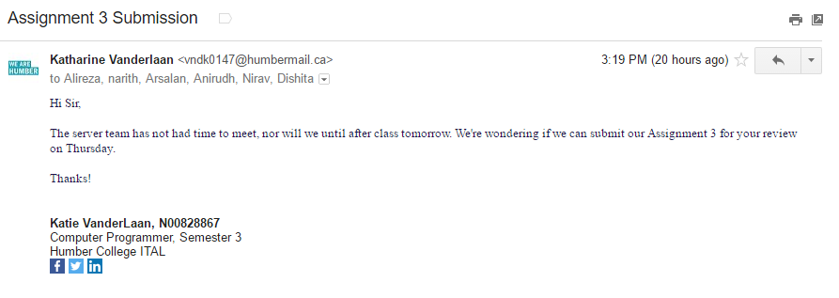

Anirudh A. created a rough draft of the sequence diagrams and emailed it to Katie. which was then forwarded to all other team members.

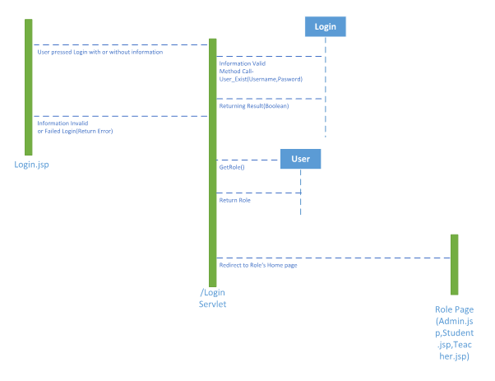

# Tues, Nov 15

It was decided that the server group would meet in class to work on the sequence diagram and to double check it against the current servlet code. Katie V. drafted the report, and updated the GitHub, which can be found at the following link: <https://github.com/vndk0147/OOAD-Servlet/>

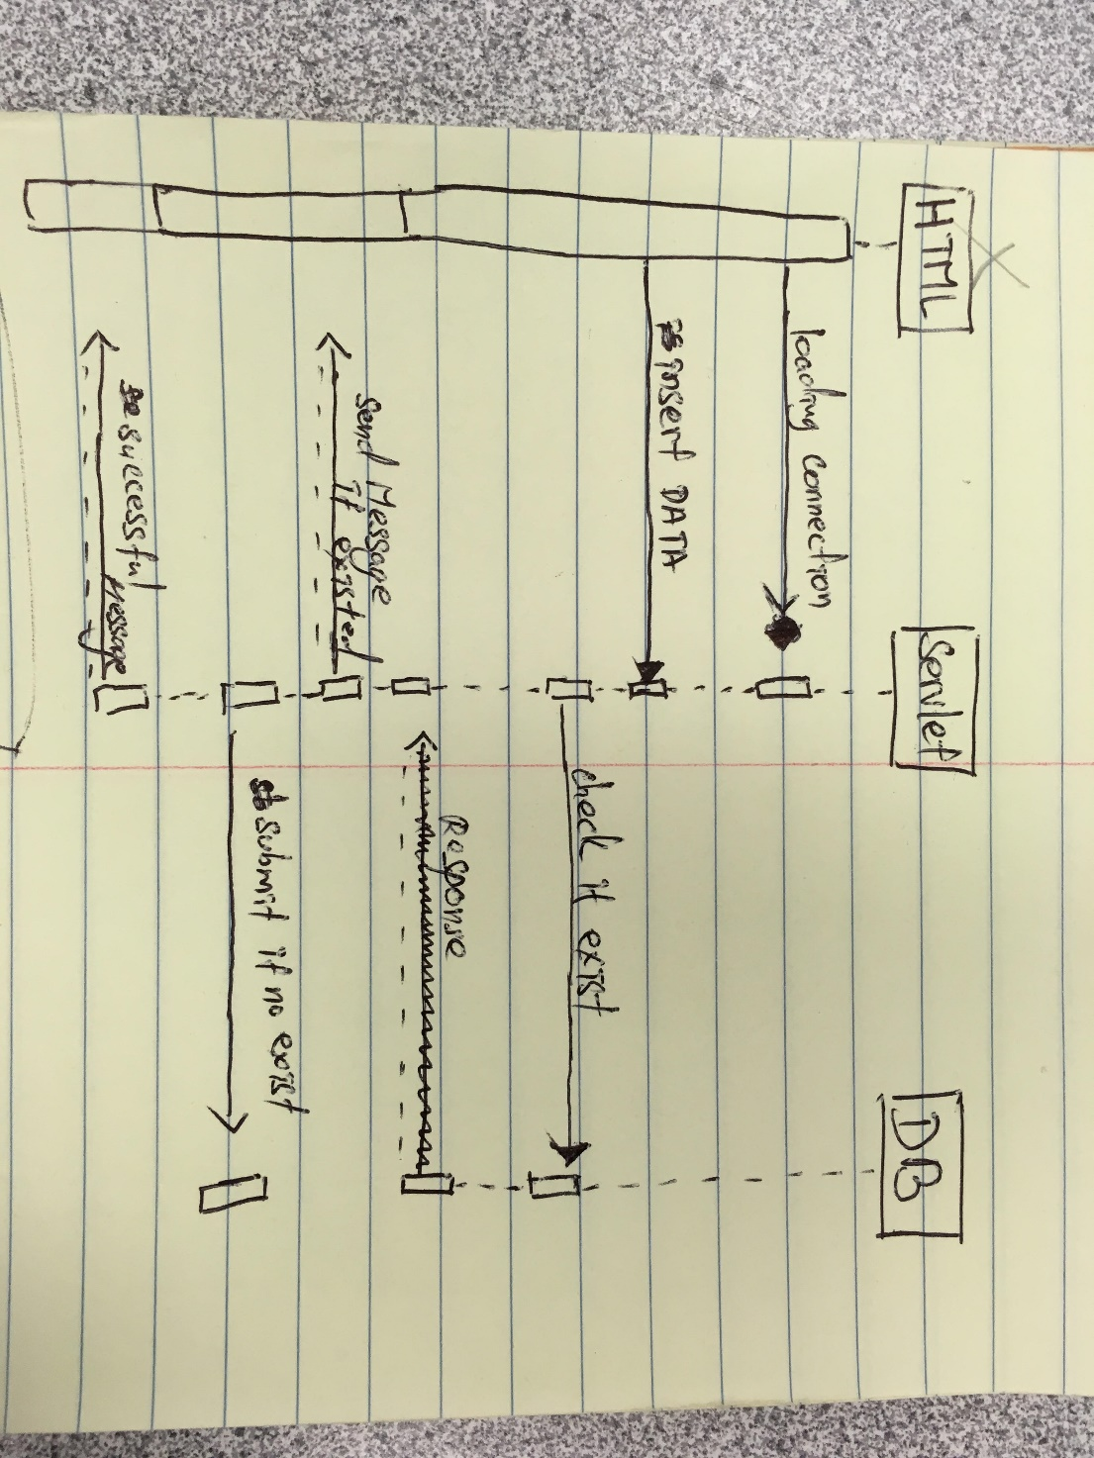Narith K. and Katie determined the rough draft did not apply to the previous assignment - because it pertained to logging in instead of scheduling an exam - and decided to create a new sequence diagram according to the code. Narith began to draw a new diagram by hand based on the class lectures on Blackboard, with assistance from Katie.

It was determined that Ali M. would be asked for assistance verifying the new draft for correctness. Narith and Katie presented the new draft to Ali, who gave the following recommendations:

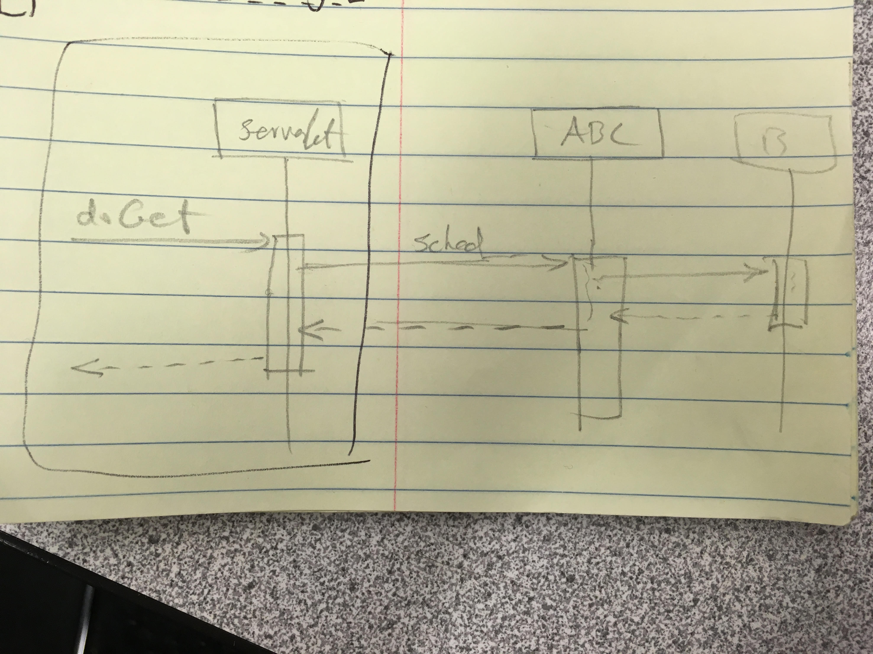

Katie created the final sequence diagram on Visual Paradigm with assistance from Narith as follows:

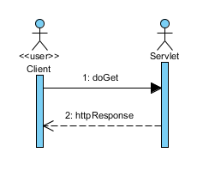

All work was then uploaded to the GitHub and members were notified. The report was updated and submitted.

It should be noted that this assignment was far too small for proper allocation amongst eight team members and as a result, Dishita P., Nirav P., Rodson B., Richard T., and Arsalan K. were - through no fault of their own – unable to participate beyond giving feedback at various points throughout the assignment’s completion. All members were available and willing to participate more had it been needed.